# Cara instalasi esp8266 wifi hotspot

Teruji di WeMos D1 Mini type C

# Alat dan bahan

* Esp8266+kabel data
* Putty
* Flashtool esp8266
* File bin

# Cara

1. Ambil file bin dan buka espflashtool . dan upload spt berikut. (jan lupa eraser all dulu)

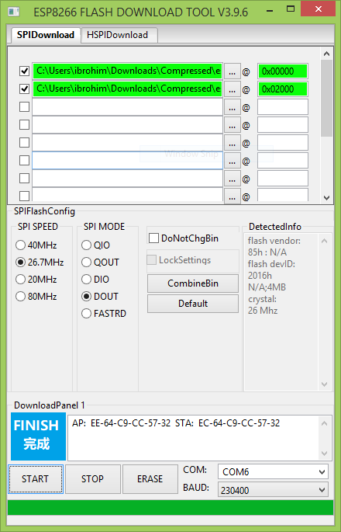

1. Restart esp lwat tombolnya
2. Buka **putty** masuk ke 192.168.4.1 7777 (saat default) 4.1 bisa diganti ip gateway jika sudah dimodif

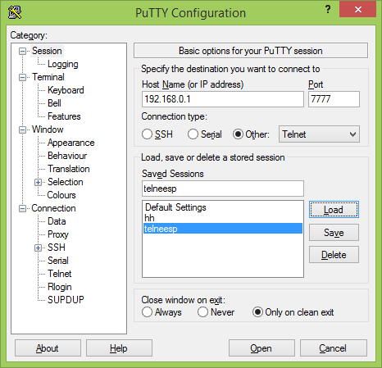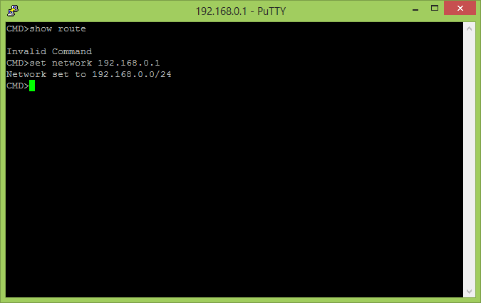

1. Done lakukan perintah dibawah yg sudah teruji. Dan peritah lainya di file pdf sebelah

# Perintah teruji

## Basic

* set ssid your_home_router's_SSID
* set password your_home_router's_password
* set ap_ssid ESP's_ssid
* set ap_password ESP's_password
* show (to check the parameters)
* save
* reset

Again, if you want to enter non-ASCII or special characters you can use HTTP-style hex encoding (e.g. "My%20AccessPoint") or, only on the CLI, as shortcut C-style quotes with backslash (e.g. "My\ AccessPoint"). Both methods will result in a string "My AccessPoint".

# Lainnya

* set status_led *GPIOno*: selects a GPIO pin for the status LED (default 2, >16 disabled) set status_led GPIOno: selects a GPIO pin for the status LED (default 2, >16 disabled)
* With "set status_led GPIOno" the GPIO pin can be changed (any value > 16, e.g. "**set status_led 255**" will disable the status LED completely). When configured to GPIO1, it works with the built-in blue LED on the ESP-01 boards. However, as GPIO1 is also the UART-TX-pin this means, that the serial console is not working. Configuration is then limited to network access.

Sumber: <https://github.com/martin-ger/esp_wifi_repeater>